William Todd

Wtodd5@students.kennesaw.edu

CS3304 Data Structures Section 05

Problem 13 Report:

The program required completing the methods required to implement the union and intersections. The methods requiring completion were stubbed out and documented with the pre-conditions, post-conditions, and comments indicating were logic should be added. A draft driver file with a main() function was also provided.

Currently, the implementation still has some problems. (List them)

-When arrays are passed to a function they will only work with the first function they are passed to, and nothing else. For example, when I have the function that will return my union first and the intersection called second it will return the union, but not the intersection. And when I call the intersection first it will return the intersection but not the union. The functions are implemented correctly as they both work when they are called first, but I cannot get them both to work at the same time.

Test Results: (screen or cut and paste from your IDE run window)

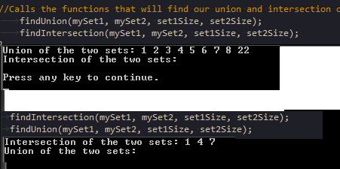

(Top is what happens when findUnion is called first, bottom is what happens when findIntersection is called first.)